Videoconferencing with Zoom

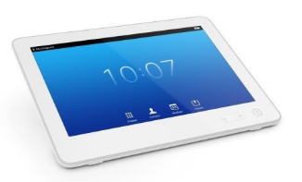
Videoconference systems are designed to join Zoom meeting and are not enabled for hosting. Zoom meetings can be joined from installed video conferencing systems, such as those found within many lecture theatres and meeting rooms on campus.

Prerequisites
- On-Prem Zoom account required
- Sip address and Meeting ID found within your Zoom invitation email provided by the host

Zoom meetings with videoconference systems
- Open Zoom app from you PC or visit the CDU website and follow the Hosting a Zoom meeting instructions and send invitation details to your meeting participants.
Website - https://charlesdarwinuni.zoom.us/
- If you are using your laptop device in the same room, mute all video and sound from zoom meeting interface to stop audio interferences in the room.

- Turn ON the AV system and switch to videoconference mode if your space has PC and videoconference setup. (See videoconference instructions in the room)
- H.323/SIP VC System
Dial the SIP or H.323 address found within the Zoom invitation email using the video conferencing system’s touch controller or remote, then enter the Meeting ID, followed by the # key.
- When connected to share your content from the touch controller panel press presentation, source (such as desktop PC) and then send content), for cisco touch panel select share.

For assistance, please contact ITMS AV Support
Phone: 8946 6291 or Ext: 6291

